SUMMARY OF PRODUCT CHARACTERISTICS

- NAME OF THE VETERINARY MEDICINAL PRODUCT

Crovect 1.25% w/v Pour-On Solution for Sheep

- QUALITATIVE AND QUANTITATIVE COMPOSITION

Active substance(s): % w/v

Cypermethrin tech. (cis:trans 80:20) 1.25

Excipient(s):
Lissamine Green B (E142) 0.02

For a full list of excipients, see section 6.1.

- PHARMACEUTICAL FORM

Pour-on solution.
Clear blue non-aqueous solution.

- CLINICAL PARTICULARS

  - Target species

Sheep

  - Indications for use, specifying the target species

For the treatment and control of headflies. For the treatment of tick infestation with a persistent efficacy of 10 weeks (the majority of ticks killed within 3 hours) and treatment of biting lice in sheep. For the prevention and treatment of blowfly strike in sheep

  - Contraindications

Not to be used in lambs less than one week old.
Avoid treating very young lambs if the weather is unseasonably hot.
For the prevention of blowfly strike; do not administer to animals of less than
12.5 kg bodyweight.

  - Special warnings for each target species

None

  - Special precautions for use

- Special precautions for use in animals

Crovect minimises mothering-up problems after treatment. However, care must be taken not to apply the product right to the lamb’s tail, as a ewe recognises a young lamb partly by the smell of the tail area.

Blowflies are attracted by dirty, damp wool or open wounds. The most common site for fly strike is the rump due to soiling caused by diarrhoea and urine staining. The efficacy of Crovect is reduced in the presence of soiled or dirty wool. Therefore, sheep must be crutched (dagged) regularly and appropriate worm control measures employed.

Take care not to apply product in the sheep’s eyes. This precaution should be observed particularly when treating breeds with little wool on their heads.

Full operating and maintenance instructions, including details on the use of nozzles are supplied with each Pour-On Gun. Please read carefully before use. Maintain gun carefully to ensure accurate dosage.

For external use only

- Special precautions to be taken by the person administering the veterinary medicinal product to animals

Make sure when attaching the Crovect Pour-On gun onto the container that the coiled retainer is secured onto the cap and the applicator.

Wear eye protection, protective clothing, rubber gloves and boots when applying the product.

Wear a disposable face-mask when applying as a fan-spray for the prevention of blowfly-strike.

Wash splashes from skin and eyes immediately with plenty of clean water. If irritation persists seek medical advice immediately

Remove contaminated clothing immediately and wash exposed skin with plenty of clean water.

Do not eat, drink or smoke whilst using the product.

Wash hands and exposed skin before eating, drinking or smoking and after work.

Use in a well-ventilated area and avoid inhaling the vapour.

- Other precautions

As a precautionary measure sheep must be kept away from watercourses for at least one hour following treatment.

  - Adverse reactions (frequency and seriousness)

None known

  - Use during pregnancy, lactation or lay

No restrictions, but handle pregnant sheep with care.

  - Interaction with other medicinal products and other forms of interaction

The product must be applied only with the Crovect Pour-On Gun, as the product may have a detrimental effect on certain components of conventional dosing guns.

  - Amounts to be administered and administration route

On completion of each treatment cycle of the product and before the dosing gun is stored, immediately expel any remaining product in the dosing gun.

Administer by means of a Crovect Pour-On Gun as follows:

Blowflies:

Prevention of blowfly strike

Bodyweight | Dose | Doses per litre
Up to 25 kg* | 20 ml | 50
25 to 40 kg | 30 ml | 33
Over 40 kg | 40 ml | 25

*Do not administer to animals of less than 12.5 kg bodyweight.

Apply as a fan-spray to the surface of the fleece on the back and hindquarters of the sheep using the Pour-On Gun fitted with the fan-spray nozzle. Half the dose should be applied to the shoulders, back and flanks, and half to the rump. The distance between the nozzle and the fleece should be approximately 20 cm. Each dose will require 2 or 3 sweeps to apply.

THE PRODUCT WILL PREVENT BLOWFLY STRIKE ONLY ON AREAS
COVERED BY SPRAY. One application will give 6-8 weeks protection. Re-treat as required.

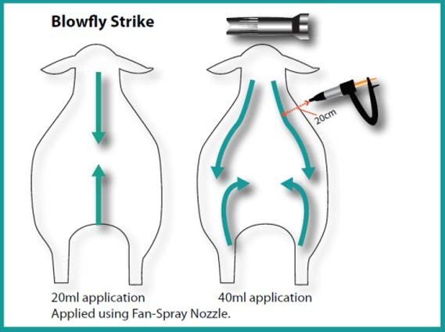

Treatment of blowfly strike

Apply directly to all the affected parts at the rate of 2.5 ml per 100 –150 cm2 (roughly the size of a hand). The T-bar nozzle should be used. Most strikes will require 5-10 ml. Ensure that all affected parts are treated. A single application is sufficient to ensure that larvae are expelled and killed within a few hours.

Lice: 5 ml per 20 kg bodyweight up to a maximum of 20 ml.

Bodyweight | Dose | Doses per litre
Up to 20 kg | 5 ml | 200
21 to 40 kg | 10 ml | 100
41 to 60 kg | 15 ml | 66
Over 60 kg | 20 ml | 50

Using the straight nozzle on the Pour-On Gun, apply as a pin-stream from the shoulders to the rump along the middle of the backline. Sheep may be treated off- shears or at any time during the year.

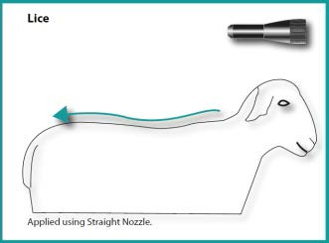

Ticks: Adult sheep and lambs greater than 10 kg: 10 ml per 20 kg bodyweight, up to a maximum of 40 ml. One treatment will give 10 weeks cover.

Lambs under 10 kg: 5 ml followed 3 weeks later by a 10 ml application.

Bodyweight  Up to 10 kg | Dose  5 ml | Doses per litre  200
11 to 20 kg | 10 ml | 100
21 to 40 kg | 20 ml | 50
41 to 60 kg | 30 ml | 33
Over 60 kg | 40 ml | 25

Using the straight nozzle on the Pour-On Gun, apply as a pin-stream from the crown of the head (see section 4.5 (i) regarding avoidance of the eyes) to the top of the rump.

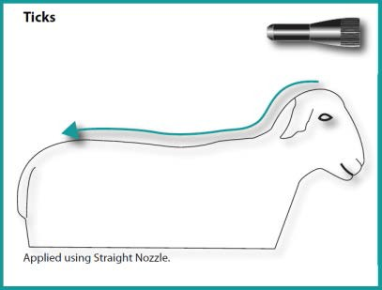

Headflies: 5 ml per animal irrespective of size.

Apply to the top of the head between the ears using the T-bar nozzle. Take care not to apply product in the sheep’s eyes.

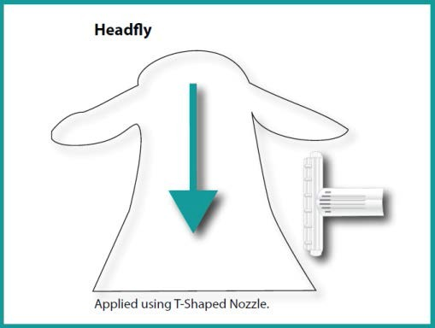

One application before the start of the headfly season will give up to 4 weeks protection. Re-treat as required.

This product contains a blue dye to aid in the identification of treated animals. The colour is temporary and will fade from the fleece within 48 hours of application.

  - Overdose (symptoms, emergency procedures, antidotes), if necessary

Toxic signs in mammals are tremors, hyperexcitability, salivation, chorea, athetosis and paralysis. The signs disappear rapidly and the animals recover, generally within a week.

There is no specific antidote but symptomatic therapy can be given if considered necessary.

  - Withdrawal period(s)

Meat: Animals must not be slaughtered for human consumption during treatment. Sheep may be slaughtered for human consumption only after 8 days from the last treatment.

Milk: Not to be administered to animals producing milk for human consumption

- PHARMACOLOGICAL PROPERTIES

Pharmacotherapeutic group: ectoparasiticides for topical use, incl. Insecticides

ATCvet code: QP53AC08

  - Pharmacodynamic properties

Cypermethrin is a neuropoison acting on the axons in the peripheral and central nervous system of insects by interacting with sodium channels.

  - Pharmacokinetic particulars

Synthetic pyrethroids are generally metabolised in mammals through ester hydrolysis, oxidation and conjugation and there is no tendency to accumulate in tissues.

- PHARMACEUTICAL PARTICULARS

  - List of excipients

Lissamine Green B (E142)
2-(2-Butoxyethoxy) ethanol

  - Incompatibilities

None known

  - Shelf life

Shelf life of the 0.8 litre and 2.2 litre veterinary medicinal product as packaged for sale: 18 months.
Shelf life of the 5.0 litre veterinary medicinal product as packaged for sale: 2 years.
Shelf life after first opening of the immediate packaging: 3 months.
  - Special precautions for storage

Do not store above 25°C. Protect from direct sunlight.
Store in tightly closed original container.
Store away from food, drink and animal feeding stuffs.

  - Nature and composition of immediate packaging

White, opaque, high density polyethylene bottle containing 0.8, 2.2 or 5 litres with either a blue, polyethylene cap (screw-fit) and an integral polyethylene induction seal or a blue, polypropylene spouted cap (screw-fit) with a hinged tamper evident lid (snap-fit).

Not all pack sizes may be marketed.

  - Special precautions for the disposal of unused veterinary medicinal product or waste materials derived from the use of such products

Any unused veterinary medicinal product or waste material derived from such veterinary medicinal products should be disposed of in accordance with local requirements.

Extremely dangerous to fish and other aquatic life. Do not contaminate ponds, waterways or ditches with the product or empty container.

- MARKETING AUTHORISATION HOLDER

Elanco Europe Ltd
Lilly House
Priestley Road Basingstoke
Hampshire
RG24 9NL

- MARKETING AUTHORISATION NUMBER

Vm 00879/4017

- DATE OF FIRST AUTHORISATION

11 March 2001

- DATE OF REVISION OF THE TEXT

August 2019

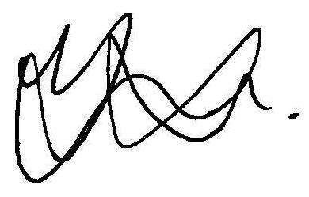
Approved: 22 August 2019

